MTH 4040 Coordinating Seminar
Dr. Fothergill
GeoGebra Lesson: Creating 3D Functions in GeoGebra
Genevieve Stinson

Review
Functions with multiple variables require us to use a three-dimensional coordinate system in order to graph them. We look at these functions on the (x,y,z) set of axes. These functions can often be difficult to visualize on our two-dimensional papers. Although we can sketch them on paper, it is difficult to manipulate them to see the full scope of the function. Programs like GeoGebra, allow us to easily graph three-dimensional functions and manipulate them, so that we gain a solid understanding of what that function looks like.
Let’s Try Graphing A 3D Function Together:
- Open GeoGebra on your computer.

- By default, GeoGebra will open to the “Algebra View” setting. In the top left corner, click on View, then click the option that says 3D Graphics in the drop down box.
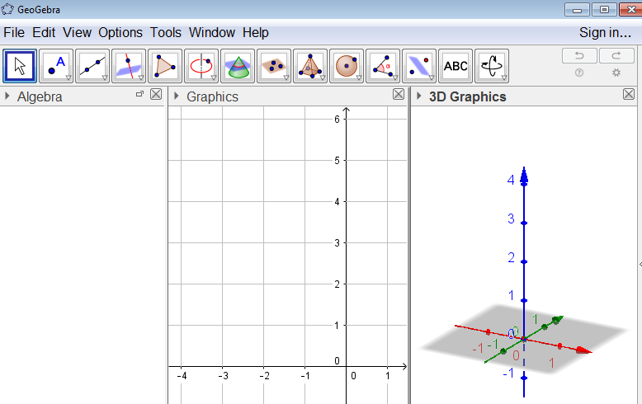
- Now, the 3D Graphics view should have popped up. We don’t need the 2D Graphics view, so you can click the “x” in the top right corner of the 2D Graphics view, to get rid of it.

- Let’s try graphing the paraboloid:
$$f\left(x,y\right)=x^{2}+y^{2}+x+y-2$$
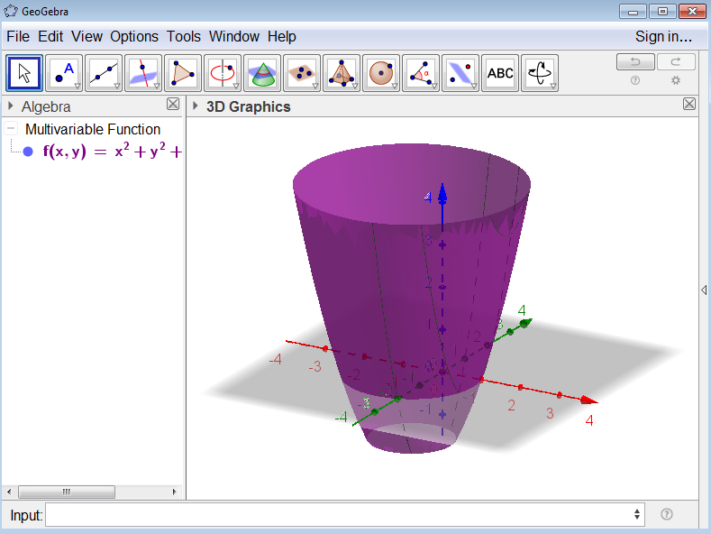
Type the function into the input bar at the bottom of the screen, exactly as you see it above, then press enter.

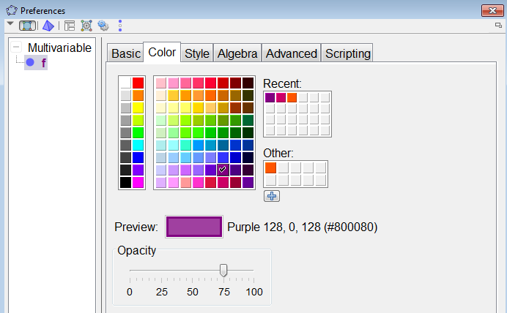
- You can change the color of the figure by right clicking on it and clicking on Object Properties. Then click on the tab that says Color, and choose the color you would like your object to be.

- By right clicking anywhere on the white space behind the graph, you can remove the light grey, shaded, (0,0,0) plane by unchecking the box next to Plane. You can also remove the axes by unchecking the box next to Axes.

- You can zoom in and out by using the scrolling button on your mouse.

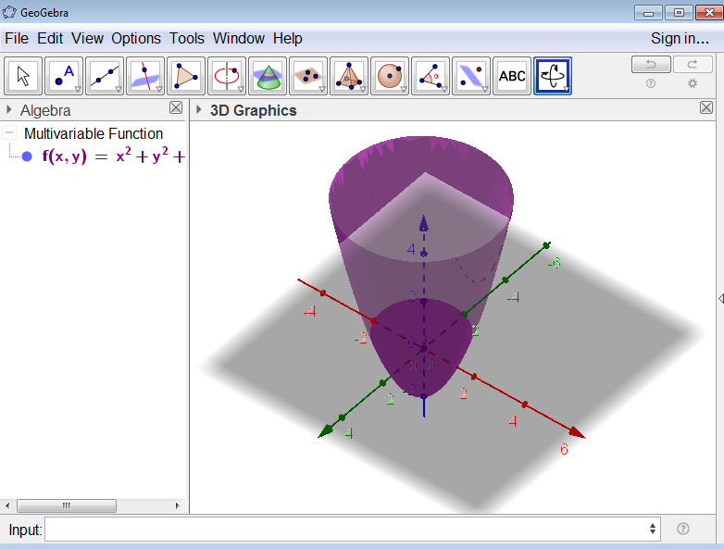
- You can rotate the object any way you’d like by clicking on the Rotate 3D Graphics View box, and clicking Rotate 3D Graphics View. Then using the mouse you can drag the object around and view it from the angle you would like.

You Try It!
Graph the equation:
$2x^{2}+3y^{2}=4z^{2}$
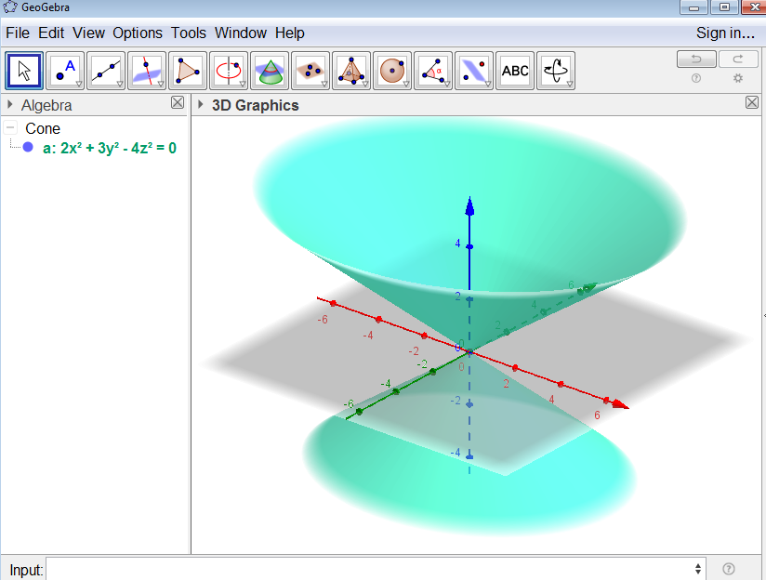
Type this equation into the input bar exactly as you see it above, then press enter.
What 3D shape do you get?

Constructing 3D Shapes Without a Direct Input
Instead of entering an equation directly into the input bar, GeoGebra allows you to construct a 3D shape by clicking points within the 3D Graphics View.
Let’s Try Constructing a Sphere Together!
- Click File > New > Don’t Save to clear the screen, and start fresh.

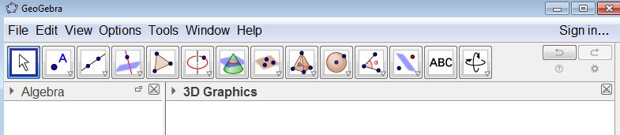
- Then, using the construction tools at the top, click on the box with the sphere in it which says Sphere with Center Through Point.

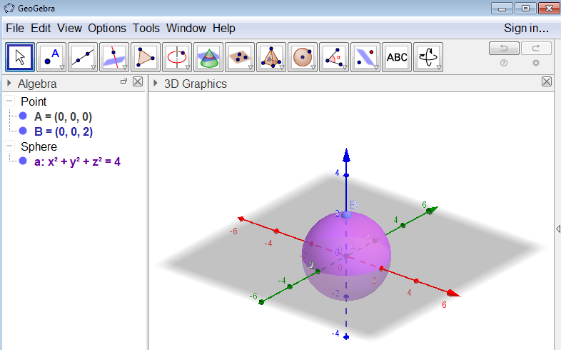
- Now click on the 3D Graphics View twice to construct your sphere. The first click will select your Center Point. The second click will be a point on your sphere.

- On the left hand side (under the word Algebra), once you’re done constructing your sphere, you will see two points: A=your center point and B=a point on your sphere. You will also see the equation for your sphere.

Another way to construct a sphere:
- Click Sphere with Center Through Point, however this time click Sphere with Center and Radius.

- Your first click will be the center of your sphere. Then a radius box will pop up. In this box, you will need to input what you would like your radius to be and click okay.

- Your sphere will be constructed, and on the left hand side you will see point A which is the center, and you will see the equation for your sphere.
Give it a Try!
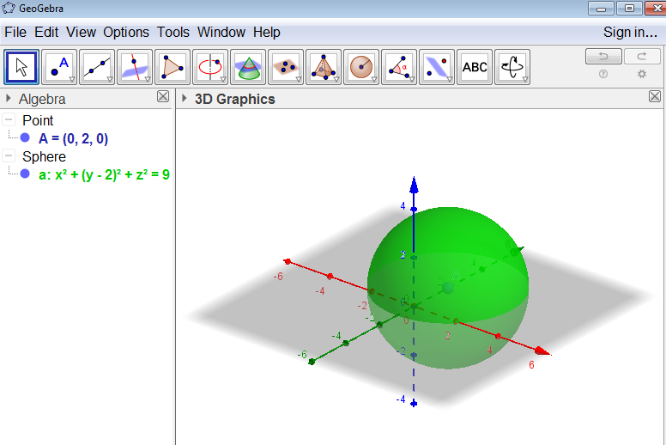
Construct a sphere with center (0,2,0) and radius 3.

It should look like this.

Extra:
GeoGebra also allows you to do constructions of cubes, pyramids, prisms, cones, cylinders, and tetrahedrons. If you have free time, feel free to explore the other constructions you can make using Geogebra.

References

"3D Graphics View." 3D Graphics View - GeoGebra Manual. N.p., n.d. Web. 07 Mar. 2017.

"Calculus, by Smith and Minton." Calculus, by Smith and Minton. N.p., n.d. Web. 07 Mar. 2017.

"Cone." Cone -- from Wolfram MathWorld. N.p., n.d. Web. 07 Mar. 2017.

